**Capstone Project - The Battle of Neighbourhoods**

Chin Ee Mei

February 12, 2021

1. **Introduction**
   1. **Introduction**

Bayan Lepas has a lot of restaurants running in business. Japanese, Korea and Chinese are the most popular restaurants in Bayan Lepas, Malaysia

* 1. **Problem Statement**

A seafood supplier from Bayan Lepas would like to know which type of Asian cuisine restaurant is the most popular in Bayan Lepas so he can his distribution centre to supply his processed seafood according to popularity.

* 1. **Target Audience**

A seafood supplier who wants to know the most popular restaurants in Bayan Lepas and the best location to set up the distribution centre for processed seafood

* 1. **Data**

To provide the information to the target audience, i will use foursquare API to collect location data to find out the highest number of restaurants among Japanese, Hong Kong and Korea Restaurants located in Bayan Lepas neighbourhoods, Penang Malaysia.

Main data source used will be data from foursquare to analyse existing restaurant in Bayan Lepas:

* 1. Location of centroid of Bayan Lepas
  2. Distance of neighbourhood from centroid of defined location, less than 10km
  3. Restaurant style ( e.g Japan, Korea, Chinese)
  4. Total Count of restaurants by style

Obtained data from FourSquare are pre-processed and filter down to restaurant located within 10km from centroid of Bayan Lepas. Key features of data are name, category, longitude, latitude and distance. Classification of restaurant according to Japan, Korea and Chinese are done. New data frame is created as below.

* 1. **Methodology**
  2. **Bar Chart**

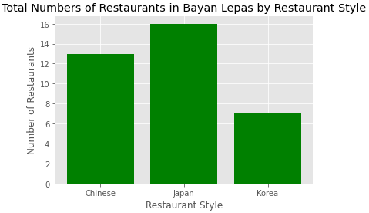

* 1. **Scatter Plot**

* 1. **Histogram**

* 1. **Result and Discussion**

a. Total 37 of our interest restaurants are within 10km neighbouring of centroid of Bayan Lepas.

b. Japanese style restaurants is the most popular restaurant. It has the highest number of restaurants within 10km neighbouring of Bayan Lepas, followed by Chinese style and Korea style.

c. Most of Japanese, Chinese and Korea restaurants are located at latitude 5.32 to latitude 5.36, and longitude 100.26 to longitude 100.31.

d. Majority of Chinese Restaurant are within 4km to 5km from centroid while Japanese restaurant are focus within distance 7km from centroid. Korean style restaurants are randomly distributed compare with other restaurants

* 1. **Conclusion**

In this study, we analysed the most popular Asian cuisine restaurant within 10km neighbouring area from centroid of Bayan Lepas. We identified Japanese style restaurant as the most popular restaurant and 2.5km to 7km of distance from centroid will be idea location to set up Japanese style processed seafood distribution centre for our target audience to provide the best service to Japanese restaurant.